View 1: Customers with Total Spend

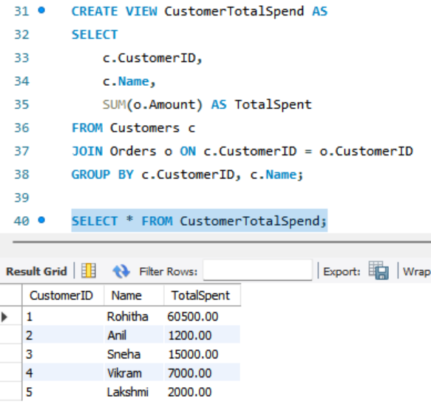

View 2: Orders Above ₹10,000

View 3: Customer Order Details (Join View)

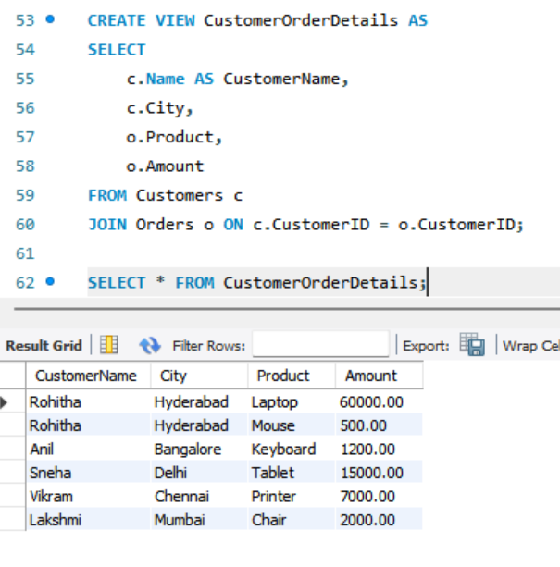

Use Views in SELECT Statements

